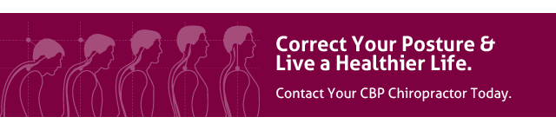

What is Chiropractic BioPhysics?
Chiropractic BioPhysics is an advanced, scientific, and proven chiropractic technique which corrects and restores your spine back to alignment.
Chiropractic BioPhysics combines biology, physiology, physics, geometry, and anatomy to identify the causes of your pain, discomfort, loss of mobility, and altered health. That means your diagnosis – and treatment – will be based on sound scientific and chiropractic principles.

What to Expect from a CBP Chiropractor?
Our doctors start with a scientifically-based examination of your posture, spinal alignment, and function – often involving x-rays as a way to pinpoint the root cause of your spinal misalignment. Once the source is identified, they will create a carefully planned series of adjustments, exercises, and a spinal reshaping program to put you on a pain-free road to better health.

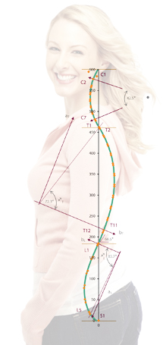
How is CBP Different from Other Techniques?
Unlike regular chiropractic that mainly focus on immediate pain relief, Chiropractic BioPhysics goes one step further to also correct the source of the problem. That’s why most patients under our care not only report relief from pain and discomfort, but as their posture begins to align, they notice other conditions clearing up as well.

Proper Spinal Alignment
Correct posture is at the core of the Chiropractic BioPhysics method of treatment. The curves in your spine act as levers, shock absorbers, and resistance to gravity; they also protect and reduce forces acting on the spinal cord and nerve tissues. But, gravity, age, poor posture, improper physical activity, injury, and disease can all play a role in the misalignment of your spinal curves and, as a result, your entire body.
Following a scientific analysis of your posture and the curvature of your spine, we will create a treatment plan based on your deficits, to restore proper alignment, relieve pain, and improve function.
Your treatment plan may include a variety of tested and proven CBP techniques, including adjustment, exercise, and traction or what is termed ‘Spinal Reshaping’
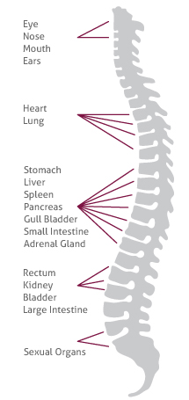

Restore Your Health
Your spine houses your nervous system – the most delicate and important organ system – responsible for your day to day bodily functions. From your immune, cardiovascular, and digestive system, to sexual function and mobility – your nerves are responsible for sending vital information and energy from the brain to your organs through your spine.
Just as a kink in a garden hose can dramatically reduce the flow of water coming from the tap – a spine out of alignment dramatically reduces vital information going from your brain to vital organs.
Thus, your organs are much more susceptible to malfunction and disease.
It’s not just coincidence that people most with poor posture tend to lack energy and suffer from fatigue, experience random aches and pains, as well as suffer from headaches/migraines, allergies, ear infection, sleeping disorders, gastrointestinal issues (such as GERD), asthma, high blood pressure, etc.
As a CBP patient, you will notice not only a dramatic decrease in pain in discomfort, but more importantly a sense of restored health and energy.

